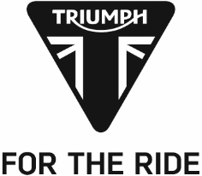
PRESS RELEASE

Triumph powers Baldassarri to third win of the season as the 765cc Moto2TM Triple continues to claim lap records

Lorenzo Baldassarri continued to stamp his authority on the Moto2™ class in 2019 with victory this weekend in Jerez, giving him three wins from four races this season. The championship leader set a new lap record in the process, 0.9 seconds faster than his own previous record from 2018.

He wasn’t the only rider setting records though, as Jorge Navarro took his Triumph-powered Speed Up machine to pole position with a new outright circuit lap record, almost 0.8 seconds faster than the previous best.

On the opening lap of the race, a four-bike crash on the exit of turn one caused a red flag and a restarted 15-lap sprint. A recovering Augusto Fernandez, who missed the last two races after surgery for a double wrist fracture sustained in a crash in Argentina, took the early lead ahead of his Flexbox HP40 teammate Baldassarri.

At middle-distance, Baldassarri took the race lead to secure another win, extending his championship lead to 17 points. Pole-sitter Navarro fought through the field having dropped to fifth on the first lap to take the fight to Fernandez, ultimately snatching second place with two laps to go, climbing to fourth in the championship.

Demonstrating the closeness of the field using the new Triumph engines, this weekend’s top speed was set with Navarro, Xavi Vierge and Alex Marquez all recording an identical 251.1 km/h.

Steve Sargent, Triumph’s Chief Product Officer, said: “After four races of our first season in Moto2, Lorenzo’s three wins is a great achievement especially given how close and competitive the series is proving to be this year. The fact that three riders set exactly the same top speed over the course of the weekend shows the level of fairness and parity that we strive for in our engine supply, and which is so important for good, close racing. With yet more lap and outright records being set this weekend the level is incredibly high, and we’re pleased that as Triumph we can play our part in making this show even more exciting.”

The Triumph Moto2™ 765cc race engine is a development of the class-leading Street Triple RS 765cc road motorcycle and produces more than 140PS and the same visceral soundtrack.

Next up, Moto2™ heads to the French Grand Prix at Le Mans on 19th May.
#PoweredByTriumph #TriumphOfficial

ENDS

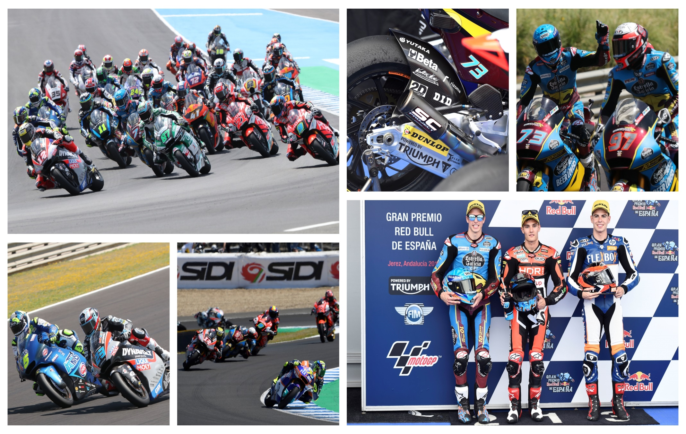
Notes to Editors

About Triumph

- The Triumph Moto2™ 765cc race engine is a development of the class-leading Street Triple RS 765cc road motorcycle and producing more than 140ps and the same visceral soundtrack.
- First established in 1902, Triumph Motorcycles celebrated 110 years of motorcycle manufacture in 2012. For more than two decades, Triumph Motorcycles has been based in Hinckley, Leicestershire, and has produced iconic bikes that perfectly blend authentic design, character, charisma and performance.

- Building around 65,000 bikes per year, Triumph is the largest British motorcycle manufacturer and has around 620 dealers across the world.

- This focus, innovation and engineering passion has today created a broad range of bikes suited to all motorcycle riders, including the iconic new Scrambler 1200, epic Speed Triple, the game changing all new Street Triple 765, the class defining Tiger 800, transcontinental Tiger 1200, iconic Triumph Bonneville family including the stunning Speed Twin, Bonneville Bobber, legendary Thruxton, accessible Street Twin, Street Scramble and iconic Bonneville T120 and T100, plus an exciting and accessible A2 range of Triumph motorcycles

- Triumph currently employs around 2,000 personnel worldwide and has subsidiary operations in the UK, North America, France, Germany, Spain, Italy, Japan, Sweden (Scandinavia), Benelux, Brazil, India and Thailand as well as a network of independent distributors. Triumph has manufacturing facilities in Hinckley, Leicestershire, and Thailand plus CKD facilities in Brazil and India.

- The Triumph Bonneville, famously named to celebrate Triumph’s 1956 land speed record on the Bonneville Salt Flats in Utah, USA, was the original British superbike and a race-winner straight out of the crate. Chosen by famous motorcyclists of the past for its legendary handling, style, and character. It’s that handling, character and style, married to modern rider-focused technology that makes the new Bonneville family THE authentic modern classic choice today.

- Triumph has a glorious racing history, competing in and winning races in almost every class and field of motorcycle sporting achievement. From winning the second ever Isle of Man TT in 1908, through to 1960s road and track domination in Europe and America, right up to contemporary racing achievements with the 675cc Triumph triple powered 2014 Daytona 200 win, the 2014 Isle of Man Supersports TT, 2014 and 2015 British Supersports titles and World SuperSport racing. And now with the new generation of 765cc triple engine powering the 2019 Moto2™ championship, Triumph’s racing legend continues.

